Andrew Tran

Programming Assignment One

Exercise One – Reactor:

#include <iostream>

#include <ctime>

#include <cstdlib>

using namespace std;

int main()

{

srand(time(NULL));

double trials = 1000;

int position = 0;

int collisions;

int collisionLimit = 10;

int oldDirection;

double escaped = 0;

for (int count = 1; count <= trials; count++)

{

position = oldDirection = collisions = 0;

while (position < 5 && position >= 0 && collisions < collisionLimit)

{

int direction = rand() % 4;

if (direction != oldDirection)

collisions++;

oldDirection = direction;

if (direction == 1)

position++;

else if (direction == 2)

position--;

}

if (position >= 5)

escaped++;

}

cout << escaped << " particles out of " << trials << " escaped. " << endl;

cout << "That equates to " << 100 * escaped / trials << "% of the particles escaped." << endl;

}

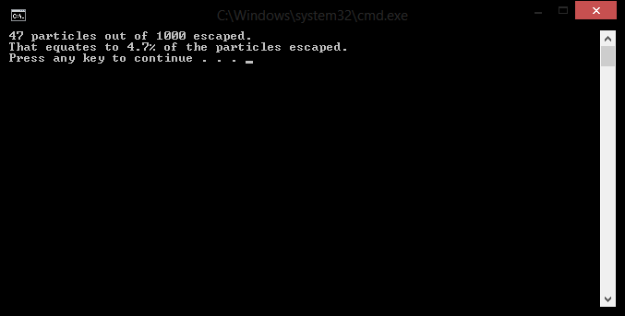

Exercise Two – Sorting:

#include <iostream>

#include <fstream>

#include <string>

#include <cctype>

using namespace std;

int main() {

int number_of_lines = 0;

ifstream myfile("GettysburghAddress.txt");

int letter = 0;

int uppercase = 0;

int punct = 0;

int whitespace = 0;

char singleCharacter;

myfile.get(singleCharacter);

while (!myfile.eof())

{

if (isupper(singleCharacter))

uppercase++;

else if (isalpha(singleCharacter))

letter++;

else if (ispunct(singleCharacter))

punct++;

else if (isspace(singleCharacter))

whitespace++;

myfile.get(singleCharacter);

}

cout << "Letters: " << letter << endl;

cout << "Uppercase: " << uppercase << endl;

cout << "Punctuation: " << punct << endl;

cout << "Whitespace: " << whitespace << endl;

}

